Vorversion The Eventers

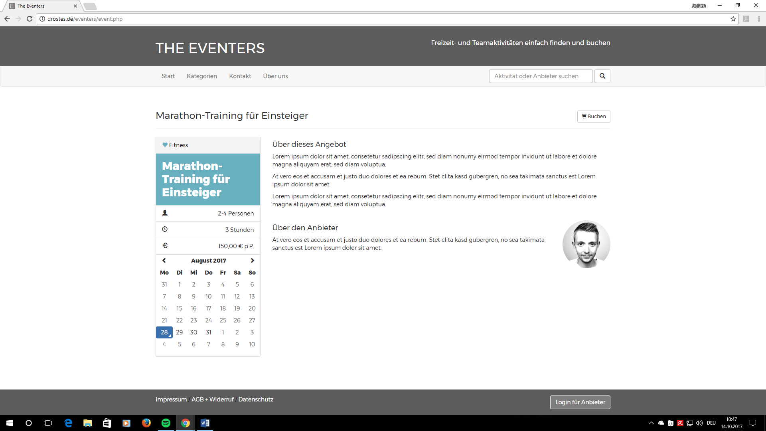

[www.getyourguide.de](http://www.getyourguide.de)

